**Expense Tracker Project - Phase 2: Salesforce Org Setup and Configuration**

**Objective:** This phase details the essential setup steps required to prepare a Salesforce developer environment for the Expense Tracker project.

**Step 1: Access Your Developer Organization**

* **Action:** Log in to your Salesforce Developer Edition org using your System Administrator credentials. If you do not have one, you will need to sign up for one.
* **Purpose:** This provides a free, sandboxed environment to build and test the application without impacting a live system.

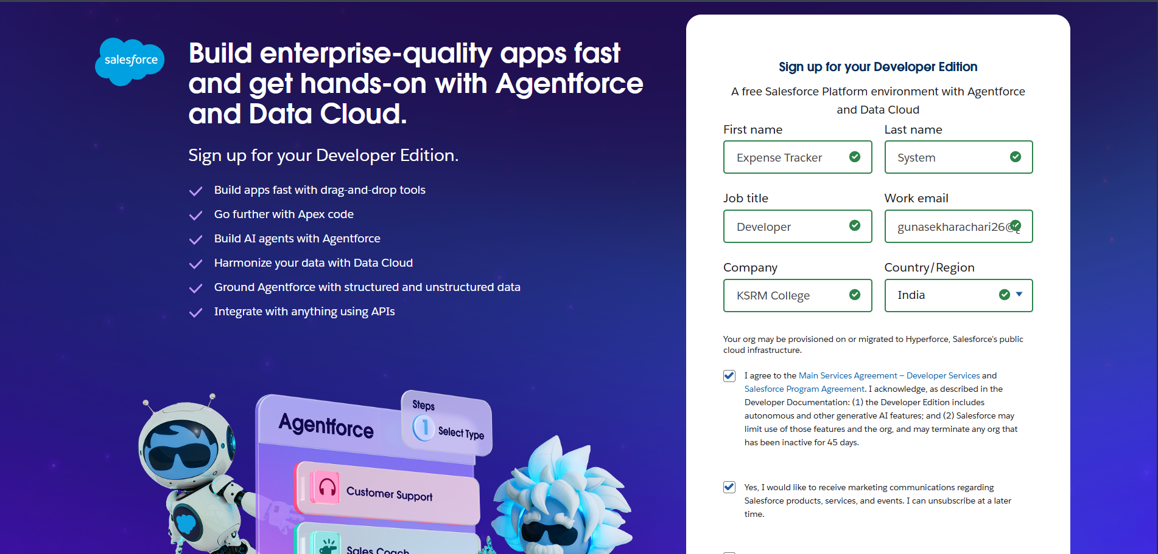

**Step 2: Configure Company Information**

1. **Navigate:** Go to Setup, use the Quick Find box to search for "Company Information," and click Edit.
2. **Settings:**
   * Set the **Company Name** to your project's name.
   * Adjust the **Default Time Zone** (e.g., GMT+05:30 India Standard Time).
   * Select the **Default Currency** (e.g., INR or USD).
3. **Save** your changes.

* **Purpose:** This configuration ensures that all date, time, and currency fields display correctly throughout the org.

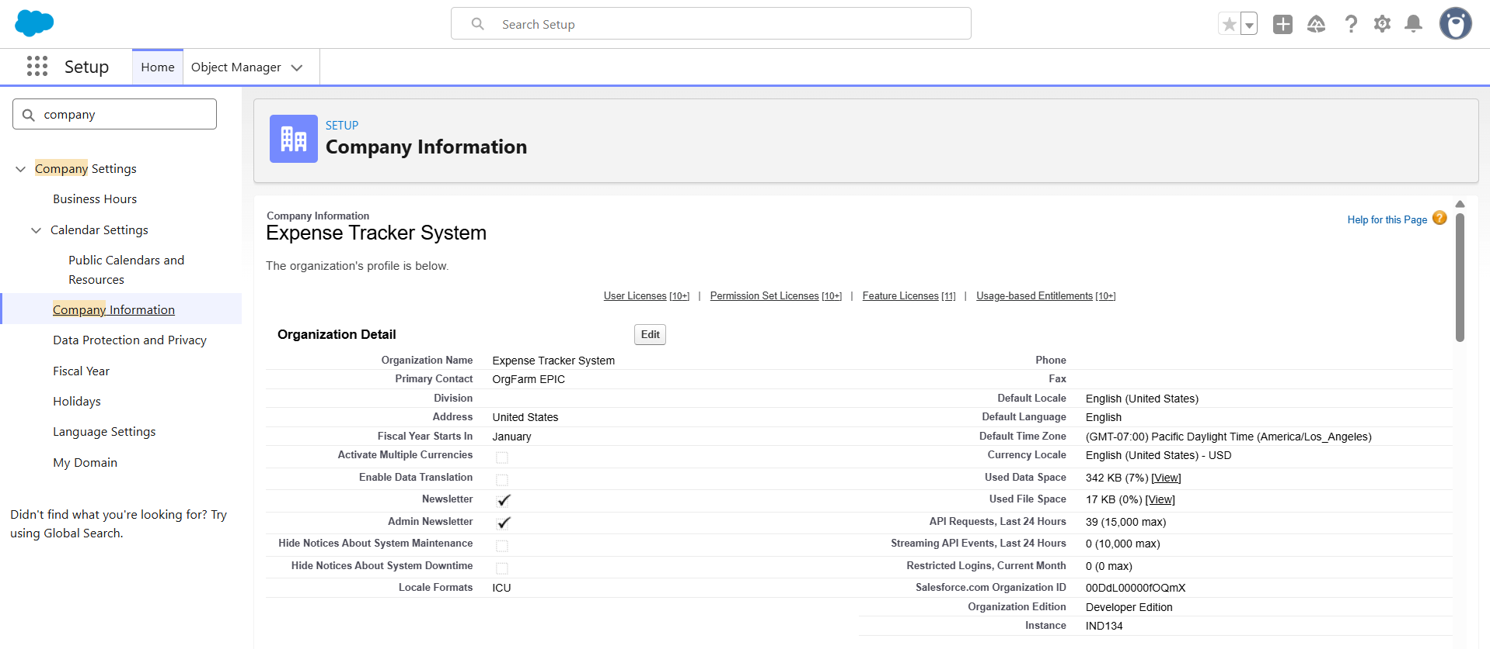

**Step 3: Set Fiscal Year**

1. **Navigate:** Go to Setup, then use Quick Find to search for "Fiscal Year".
2. **Action:** Confirm that the "Standard Fiscal Year" (January-December) is selected.
3. **Save** if you made any modifications.

* **Purpose:** Establishes standard reporting periods, which is crucial for future expense and revenue reporting.

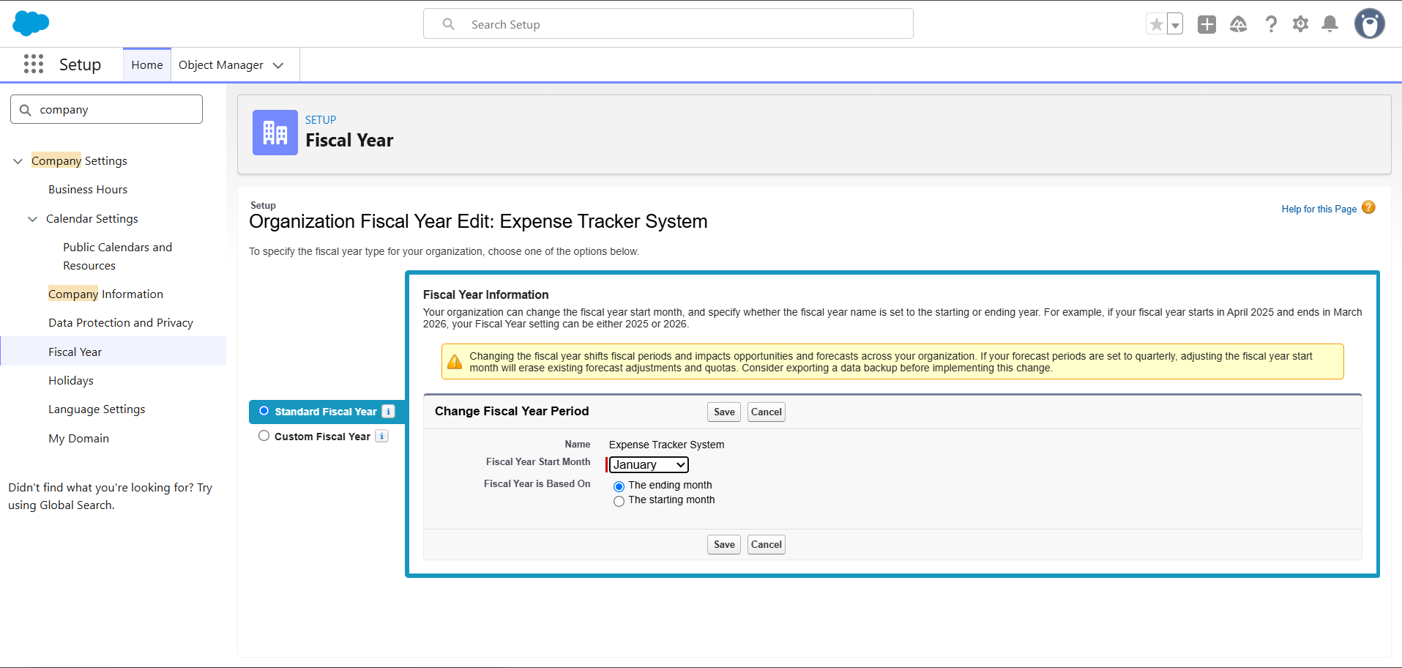

**Step 4: Establish Role Hierarchy**

1. **Navigate:** Go to Setup, use Quick Find to search for "Roles," and select "Set Up Roles".
2. **Create Roles:**
   * Define a top-level role, such as "Manager".
   * Create a child role under "Manager," such as "Employee/Agent".
3. **Save** the new hierarchy.

* **Purpose:** The role hierarchy is essential for record visibility. It allows managers to view records owned by their subordinates when Organization-Wide Defaults (OWD) are set to Private.

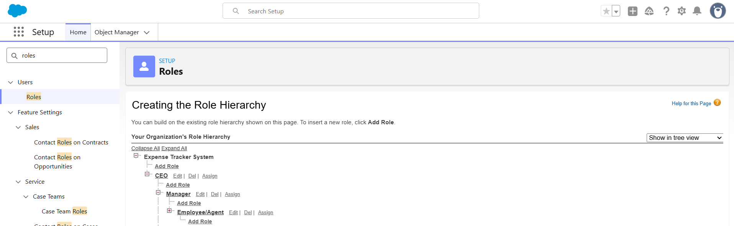

**Step 5: Create Project Users**

1. **Navigate:** Go to Setup, use Quick Find to search for "Users," and click "New User".
2. **Create Manager User:**
   * **Profile:** System Administrator (This is the fastest for demonstration purposes).
   * **Role:** Manager.
   * Complete all required fields: Name, Email, Username, Alias, Time Zone, and Locale.
   * Click **Save**.
3. **Create Employee User:**
   * **Profile:** Standard User.
   * **Role:** Employee.
   * Complete all required fields: Name, Email, Username, Alias, Time Zone, and Locale.
   * Click **Save**.
4. **Update Employee Record:** After saving the Employee user, you must **edit their record** and set the "Manager" lookup field to point to the Manager user you created. Save the record again.

* **Purpose:** This structure is critical for role-based visibility and approval processes, which rely on the Manager link and the defined role hierarchy.

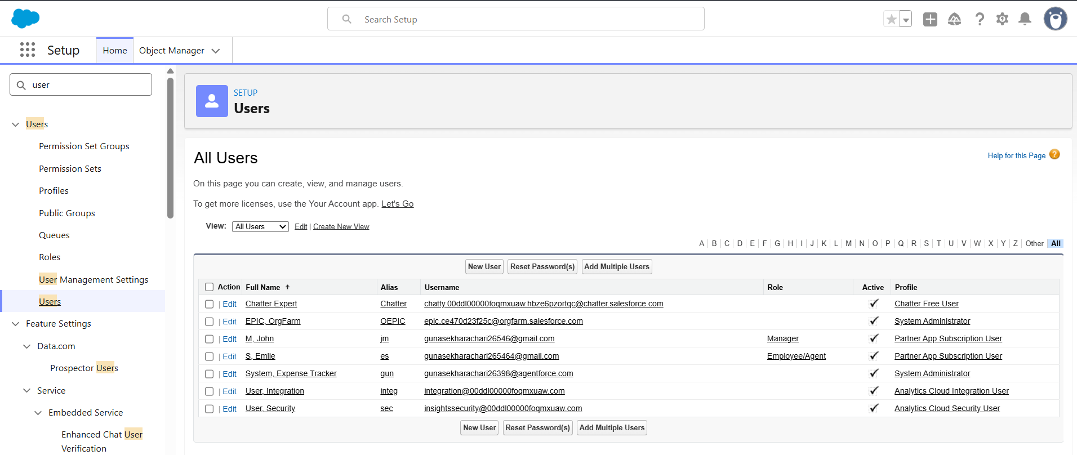

**Step 6: Clone the Standard Profile**

1. **Navigate:** Go to Setup, use Quick Find for "Profiles." Select the "Standard User" profile and click "Clone".
2. **New Profile Name:** Enter "Expense Employee Profile".
3. **Save** the new profile.

* **Purpose:** This creates a custom profile for employees, allowing you to set minimal permissions without altering the default Standard User profile.

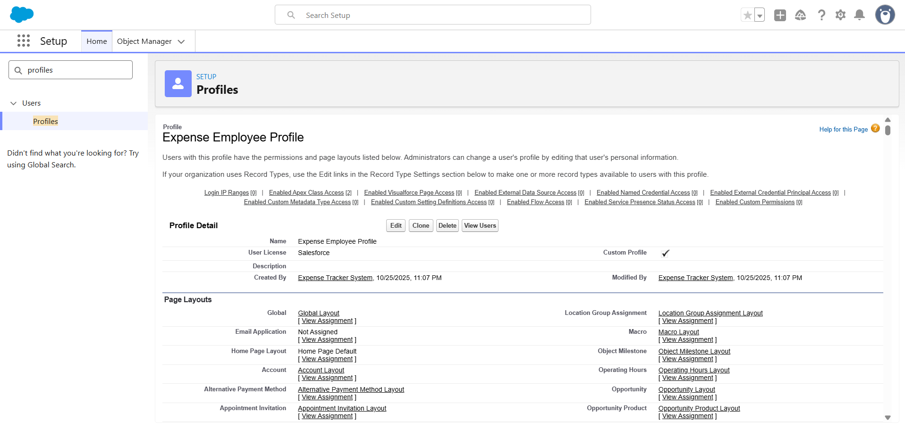

**Step 7: Configure Org-Wide Defaults (OWD)**

1. **Navigate:** Go to Setup, use Quick Find for "Sharing Settings," and click "Edit".
2. **Set:** Find the "Expense__c" object and set its default access to **Private**. (Note: This object must be created first).
3. **Save** the changes.

* **Purpose:** Setting the OWD to Private ensures that, by default, only the record owner and their manager (via the role hierarchy) can view an expense record.

**Step 8: Set Profile and Field-Level Security**

*(This step should be performed after the Expense custom object and its fields have been created)*

* **Step 8A: Field-Level Security (FLS)**
  + **Navigate:** Go to Setup → Object Manager → Expense → Fields & Relationships.
  + **Action:** For each field, click its name, select "Set Field-Level Security," and ensure the "Visible" checkbox is checked for the "Expense Employee Profile" and the Manager/Admin profile.
* **Step 8B: Profile Object Access**
  + **Navigate:** Go to Setup → Profiles → Expense Employee Profile.
  + **Action:** Find "Object Settings" → "Expense" → "Edit".
  + **Permissions:** Grant Read, Create, and Edit access (Delete is optional). Click **Save**.
* **Purpose:** This configuration ensures that employees have the necessary permissions to create and manage their own expense records , while managers can review them.

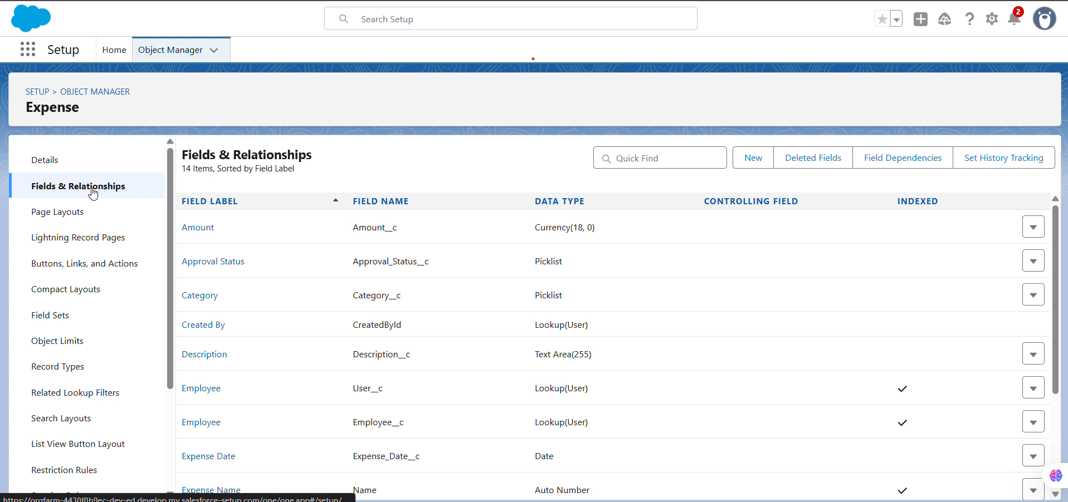

**Step 9: Quick Validation Test**

1. Log in to Salesforce as the "Employee User" and create a new "Expense" record.
2. Log out, then log in as the "Manager User." Verify that you can see the expense record created by the employee.
3. **Confirm:** This test validates that the role hierarchy and OWD settings are working correctly.

* **Purpose:** This validation confirms the security and sharing setup before proceeding to Phase 3 (object creation and relationships).

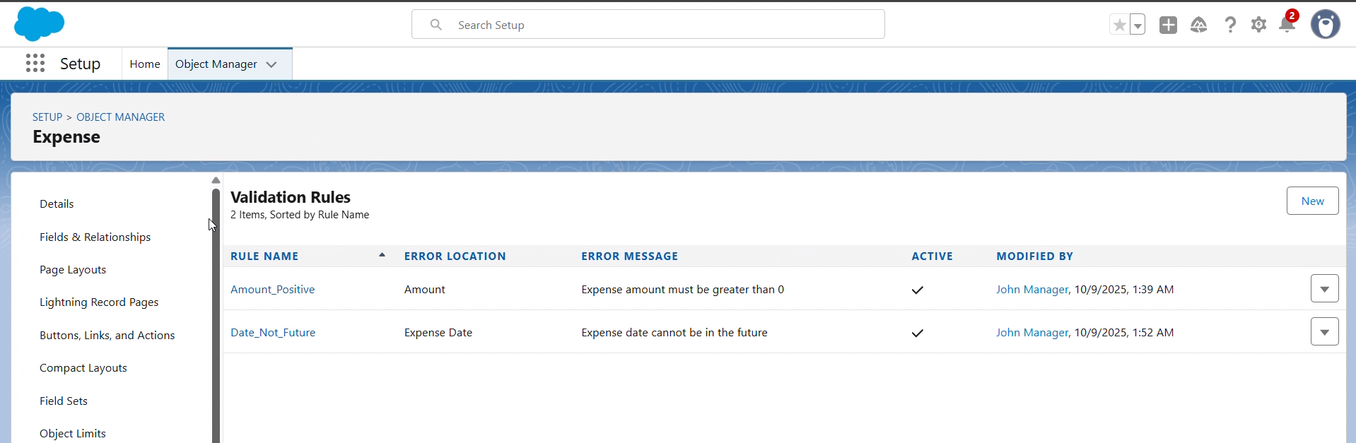

**Phase 2 Completion**

* The Salesforce organization is now minimally configured for the Expense Tracker project.
* You are now ready to proceed to Phase 3: Creating objects, fields, and relationships.